2020 International Conference on Thermodynamics and Thermal Metamaterials (ThermoMeta2020)
http://econophysics.fudan.edu.cn/jphuang/ThermoMeta2020

Reply slip
Notes: Just replace the blue text below, and email your Reply Slip to the two addresses simultaneously: <19210190010@fudan.edu.cn> and <ThermoMeta2020@gmail.com>. Students are also required to give oral talks.

- Name (Given name/Family name): Jun Wang
- Affiliation: Fudan University, Shanghai 200438, China
- Position [Prof./Assoc. Prof./Assis. Prof./Postdoc/Student/Other (please specify)]: Student
- Email: 16210190020@fudan.edu.cn
- Web (keep blank if you donot have): http://econophysics.fudan.edu.cn/jphuang/
- Mobile phone No.: ++86-1356466603
- Office phone No.: ++86-21-31242017
- Wechat No. (keep blank if you donot have): foool-fudan
- Preferred time slots for your pre-recorded oral presentation and Q/A: B, C, or D
A. August 7, Friday, afternoon (1:30 pm – 5:00 pm, GMT+8, Beijing Time)
B. August 8, Saturday, morning (8:00 am – 11:30 am, GMT+8, Beijing Time)
C. August 8, Saturday, afternoon (1:30 pm – 5:00 pm, GMT+8, Beijing Time)
D. August 9, Sunday, morning (8:00 am – 11:30 am, GMT+8, Beijing Time)

Title of your pre-recorded oral presentation: Origin of thermal metamaterials for controlling macroscopic heat transfer at will
Full author list: Shuai Yangª, Jun Wang^{b}, Gao-Le Dai^{a,b}, and Fu-Bao Yang^{a,b}
Affiliation:
ªDepartment of Physics and State Key Laboratory of Surface Physics, Fudan University, Shanghai 200438, China
^{b}Key Laboratory of Micro and Nano Photonic Structures (MOE), Fudan University, Shanghai 200438, China
Speaker (for the pre-recorded presentation and its following Q/A): Jun Wang
Abstract (less than 300 words): As shown in the following Figure, since the seminal article by V. G. Veselago in 1968 and especially the other two seminal articles by J. B. Pendry and coauthors in 1996 and 1999, the field of metamaterial physics has grown vigorously until today. With the aid of the concept of metamaterials, many fundamental physics have been discovered in various branches of physics, ranging from optics/electromagnetics to elasticity/acoustics/mechanics/…… for wave systems, and from thermotics to particle dynamics for diffusion systems. As a result, various kinds of metamaterials were theoretically designed and experimentally fabricated in such branches. Here we focus on the branch of thermotics, namely, thermal metamaterials. The phrase “thermal metamaterial” was first adopted in Ref. [1] to name thermal cloaks (shields) and relevant devices designed by using transformation thermotics for heat conduction (diffusion) studied in Refs. [2–6]. Owing to the existence of three basic ways of heat transfer (i.e., conduction, convection, and radiation), nowadays the connotation of “thermal metamaterial” has naturally been extended to include metamaterials for controlling heat convection and radiation [7]. Incidentally, thermal metamaterials also contain some thermal metadevices (whose novel functions are realized mainly because of specific geometric structures), to comply with the common usage in the literature. We will conclude the talk with some personal views on the future for the exciting field of thermal metamaterials for controlling heat transfer at will.

Figure (with figure caption; only one):
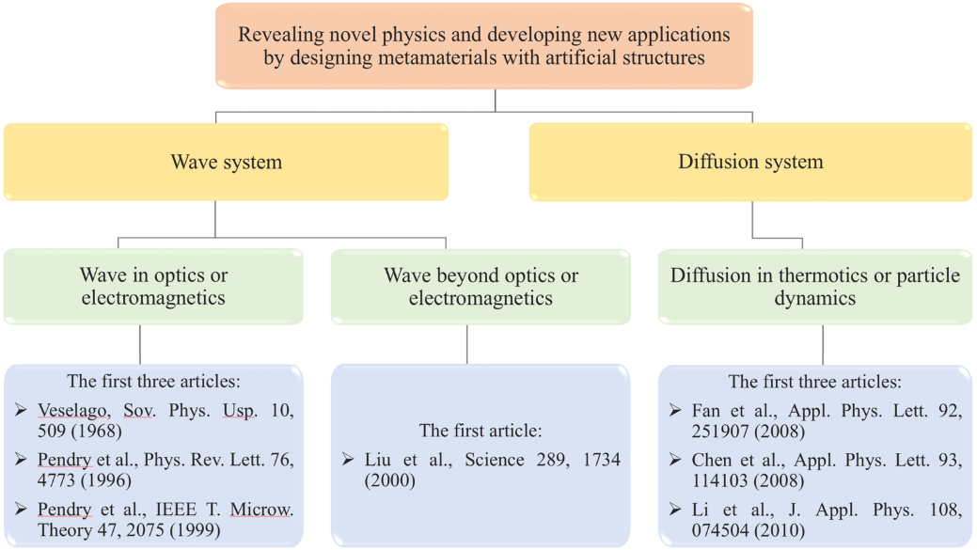
A large number of novel physics and applications have arisen from metamaterials with artificial structures for wave systems and diffusion systems since 1968 (electromagnetic wave) and 2008 (thermal conduction), respectively. Both waves and diffusion are two important methods for transferring energy.

Key References (less than 10):
[1] M. Maldovan, Sound and heat revolutions in phononics, Nature 503, 209–217 (2013)
[2] C. Z. Fan, Y. Gao, and J. P. Huang, Shaped graded materials with an apparent negative thermal conductivity, Appl. Phys. Lett. 92, 251907 (2008)
[3] T. Y. Chen, C. N. Weng, and J. S. Chen, Cloak for curvilinearly anisotropic media in conduction, Appl. Phys. Lett. 93, 114103 (2008)
[4] S. Guenneau, C. Amra, and D. Veynante, Transformation thermodynamics: Cloaking and concentrating heat flux, Opt. Express 20, 8207–8218 (2012)
[5] S. Narayana and Y. Sato, Heat flux manipulation with engineered thermal materials, Phys. Rev. Lett. 108, 214303 (2012)
[6] R. Schittny, M. Kadic, S. Guenneau, and M. Wegener, Experiments on transformation thermodynamics: Molding the flow of heat, Phys. Rev. Lett. 110, 195901 (2013)
[7] J. P. Huang, Theoretical thermotics: Transformation thermotics and extended theories for thermal metamaterials (Springer, 2020)

Photo of the Speaker (ThermoMeta2020 is e-conference; the audience do hope to “see” you, at least on the screen):
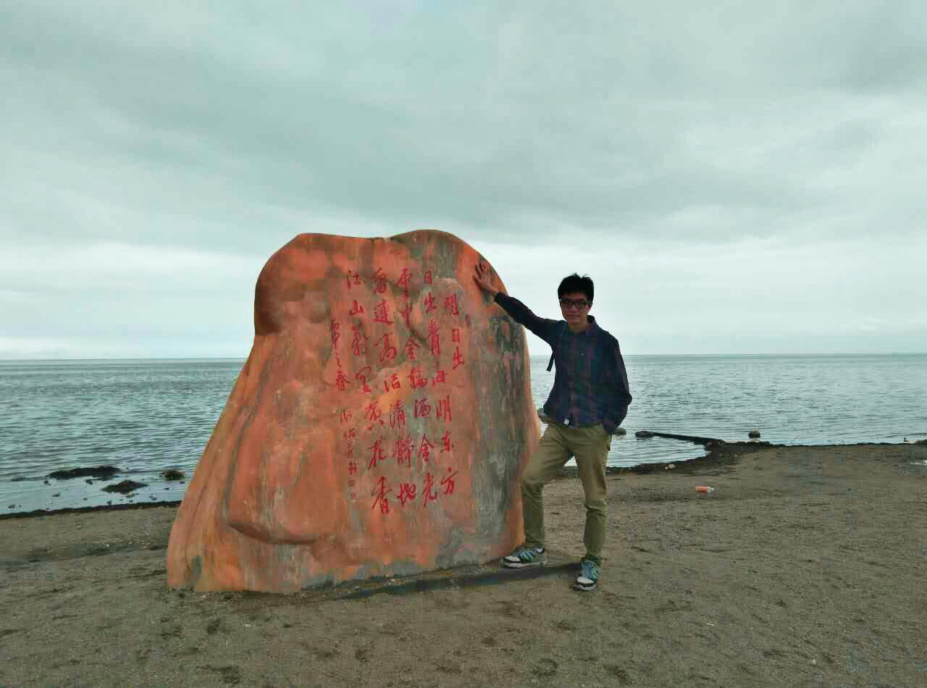
Speaker: Jun Wang

